**Practical No 1 : Write a program to print Android lifecycle method calls in logcat.**

**MainActivity.java**

package android.cycle.life.com.lifecycleandroid;  
import android.support.v7.app.AppCompatActivity;  
import android.os.Bundle;  
import android.util.Log;  
public class MainActivity extends AppCompatActivity {  
 @Override  
 protected void onCreate(Bundle savedInstanceState) {  
 super.onCreate(savedInstanceState);  
 setContentView(R.layout.activity_main);  
  
 Log.i("Life Cycle", "OnCreate Called");  
 }  
 @Override  
 protected void onStart() {  
 super.onStart();  
 Log.i("Life Cycle", "OnStart Called");  
 }  
 @Override  
 protected void onResume() {  
 super.onResume();  
 Log.i("Life Cycle", "OnResume Called");  
 }  
 @Override  
 protected void onPause() {  
 super.onPause();  
 Log.*i*("Life Cycle", "OnPause Called");  
 }  
 @Override  
 protected void onStop() {  
 super.onStop();  
 Log.*i*("Life Cycle", "OnStop Called");  
 }  
 @Override  
 protected void onRestart() {  
 super.onRestart();  
 Log.*i*("Life Cycle", "OnRestart Called");  
 }  
 @Override  
 protected void onDestroy() {  
 super.onDestroy();  
 Log.*i*("Life Cycle", "OnDestroy Called");  
 }  
}

**Output:**

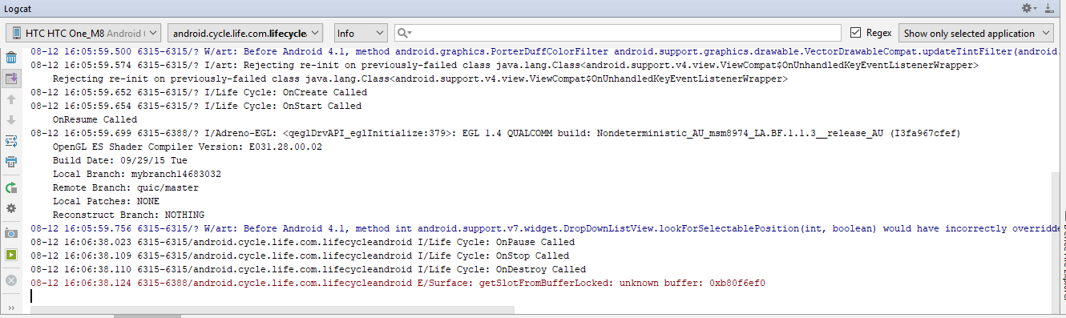

**Practical No 2 : Design a registration form in LinearLayout & RelativeLayout**

**Activity_main.xml**

*<?*xml version="1.0" encoding="utf-8"*?>*<RelativeLayout xmlns:android="http://schemas.android.com/apk/res/android"  
 xmlns:app="http://schemas.android.com/apk/res-auto"  
 xmlns:tools="http://schemas.android.com/tools"  
 android:layout_width="match_parent"  
 android:layout_height="match_parent"  
 android:padding="20dp"  
 tools:context=".MainActivity">  
  
 <EditText  
 android:id="@+id/nameEditText"  
 android:layout_width="match_parent"  
 android:layout_height="wrap_content"  
 android:hint="Enter the name"  
 android:layout_marginTop="16dp"/>  
  
 <EditText  
 android:id="@+id/ageEditText"  
 android:layout_width="match_parent"  
 android:layout_height="wrap_content"  
 android:hint="Enter the age"  
 android:inputType="number"  
 android:layout_below="@id/nameEditText"  
 android:layout_marginTop="16dp"/>  
  
 <EditText  
 android:id="@+id/emailEditText"  
 android:layout_width="match_parent"  
 android:layout_height="wrap_content"  
 android:hint="Enter the email"  
 android:layout_below="@id/ageEditText"  
 android:layout_marginTop="16dp"/>  
  
 <EditText  
 android:id="@+id/phoneEditText"  
 android:layout_width="match_parent"  
 android:layout_height="wrap_content"  
 android:inputType="phone"  
 android:hint="Enter the phone number"  
 android:layout_below="@id/emailEditText"  
 android:layout_marginTop="16dp"/>  
  
 <TextView  
 android:id="@+id/genderTextView"  
 android:layout_width="wrap_content"  
 android:layout_height="wrap_content"  
 android:layout_below="@id/phoneEditText"  
 android:text="Gender : "  
 android:textSize="16sp"  
 android:layout_marginTop="16dp"/>  
  
 <RadioGroup  
 android:id="@+id/genderRadioGroup"  
 android:layout_width="match_parent"  
 android:layout_height="wrap_content"  
 android:layout_marginTop="16dp"  
 android:orientation="horizontal"  
 android:layout_below="@id/phoneEditText"  
 android:layout_toRightOf="@id/genderTextView"  
 android:text="Gender">  
  
 <RadioButton  
 android:id="@+id/maleRadioButton"  
 android:layout_width="wrap_content"  
 android:layout_height="wrap_content"  
 android:text="Male" />  
  
 <RadioButton  
 android:id="@+id/femaleRadioButton"  
 android:layout_width="wrap_content"  
 android:layout_height="wrap_content"  
 android:text="Female" />  
  
 </RadioGroup>  
  
 <LinearLayout  
 android:layout_width="match_parent"  
 android:layout_height="wrap_content"  
 android:orientation="horizontal"  
 android:weightSum="2"  
 android:layout_below="@id/genderRadioGroup"  
 android:layout_marginTop="16dp">  
  
 <Button  
 android:id="@+id/submitButton"  
 android:layout_width="wrap_content"  
 android:layout_height="wrap_content"  
 android:layout_weight="1"  
 android:text="Submit"/>  
  
 <Button  
 android:id="@+id/clearButton"  
 android:layout_width="wrap_content"  
 android:layout_height="wrap_content"  
 android:layout_weight="1"  
 android:text="Clear"/>  
  
 </LinearLayout>  
  
</RelativeLayout>

**MainActivity.java**

package form.registration.com.registrationform;  
  
import android.support.v7.app.AppCompatActivity;  
import android.os.Bundle;  
import android.view.View;  
import android.widget.Button;  
import android.widget.EditText;  
import android.widget.RadioButton;  
import android.widget.RadioGroup;  
import android.widget.Toast;  
public class MainActivity extends AppCompatActivity {  
 private EditText nameEditText;  
 private EditText ageEditText;  
 private EditText emailEditText;  
 private EditText phoneEditText;  
 private RadioGroup genderRadioGroup;  
 private RadioButton radioButton;  
 private Button submitButton;  
 private Button clearButton;  
 @Override  
 protected void onCreate(Bundle savedInstanceState) {  
 super.onCreate(savedInstanceState);  
 setContentView(R.layout.*activity_main*);  
 nameEditText = findViewById(R.id.*nameEditText*);  
 ageEditText = findViewById(R.id.*ageEditText*);  
 emailEditText = findViewById(R.id.*emailEditText*);  
 phoneEditText = findViewById(R.id.*phoneEditText*);  
 genderRadioGroup = findViewById(R.id.*genderRadioGroup*);  
 submitButton = findViewById(R.id.*submitButton*);  
 clearButton = findViewById(R.id.*clearButton*);

submitButton.setOnClickListener(new View.OnClickListener() {  
 @Override  
 public void onClick(View view) {  
 String name = nameEditText.getText().toString();  
 String age = ageEditText.getText().toString();  
 String email = emailEditText.getText().toString();  
 String phone = phoneEditText.getText().toString();  
 int genderId = genderRadioGroup.getCheckedRadioButtonId();  
 radioButton = findViewById(genderId);  
 String gender = radioButton.getText().toString();  
 Toast.*makeText*(MainActivity.this,"Name : " +name + "\nAge : " +age+  
 "\nEmail ID : "+email+ "\nPhone : "+phone+"\n Gender : "+gender, Toast.*LENGTH_LONG*).show();  
 clearText();  
 }  
 });  
  
 clearButton.setOnClickListener(new View.OnClickListener() {  
 @Override  
 public void onClick(View view) {  
 clearText();  
 }  
 });  
  
 }  
  
 private void clearText() {  
 nameEditText.setText("");  
 ageEditText.setText("");  
 emailEditText.setText("");  
 phoneEditText.setText("");  
 genderRadioGroup.clearCheck();  
 }  
}

**Output:**

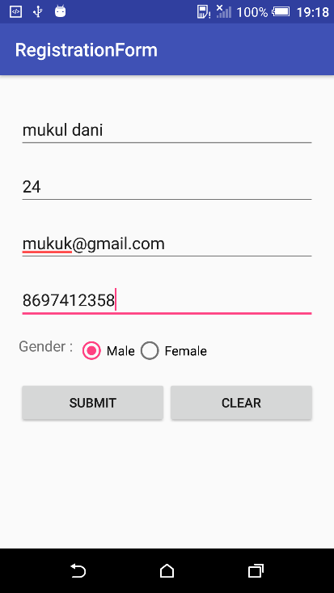 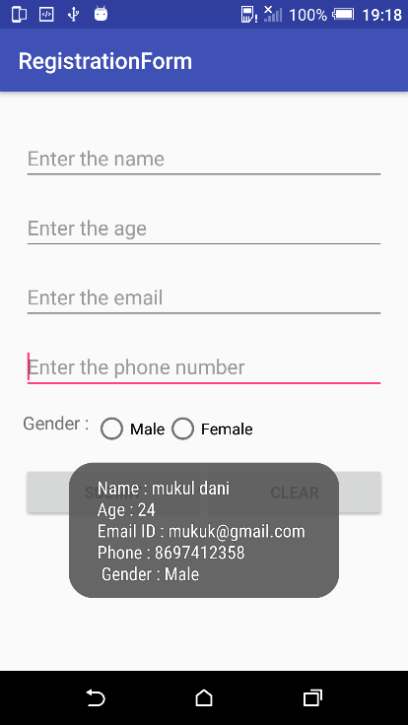

**Practical 3 :** **Create a simple calculator application to perform addition, subtraction, multiplication and division.**

**Activity_main.xml**

*<?*xml version="1.0" encoding="utf-8"*?>*<LinearLayout xmlns:android="http://schemas.android.com/apk/res/android"  
 xmlns:app="http://schemas.android.com/apk/res-auto"  
 xmlns:tools="http://schemas.android.com/tools"  
 android:layout_width="match_parent"  
 android:layout_height="match_parent"  
 android:orientation="vertical"  
 android:padding="20dp"  
 tools:context=".MainActivity">  
  
 <EditText  
 android:id="@+id/number1EditText"  
 android:layout_width="match_parent"  
 android:layout_height="wrap_content"  
 android:hint="Enter the first number"/>  
  
 <EditText  
 android:id="@+id/number2EditText"  
 android:layout_width="match_parent"  
 android:layout_height="wrap_content"  
 android:hint="Enter the second number"/>  
  
 <RelativeLayout  
 android:layout_width="match_parent"  
 android:layout_height="match_parent"  
 android:orientation="horizontal"  
 android:layout_marginTop="10dp">  
  
 <Button  
 android:id="@+id/addButton"  
 android:layout_width="wrap_content"  
 android:layout_height="wrap_content"  
 android:text="Addition"/>  
  
 <Button  
 android:id="@+id/subtractButton"  
 android:layout_width="wrap_content"  
 android:layout_height="wrap_content"  
 android:text="Subtraction"  
 android:layout_toRightOf="@id/addButton"/>  
  
 <Button  
 android:id="@+id/multButton"  
 android:layout_width="wrap_content"  
 android:layout_height="wrap_content"  
 android:text="Multiply"  
 android:layout_below="@id/addButton"/>  
  
 <Button  
 android:id="@+id/divisionButton"  
 android:layout_width="wrap_content"  
 android:layout_height="wrap_content"  
 android:text="Division"  
 android:layout_below="@id/addButton"  
 android:layout_toRightOf="@id/multButton"/>  
  
 <TextView  
 android:id="@+id/resultTextView"  
 android:layout_width="wrap_content"  
 android:layout_height="match_parent"  
 android:visibility="gone"  
 android:layout_below="@id/divisionButton"  
 android:layout_centerHorizontal="true"  
 android:layout_centerVertical="true"  
 android:textSize="20sp"  
 android:textStyle="bold"/>  
  
 </RelativeLayout>  
  
</LinearLayout>

**MainActivity.java**

package caluclator.com.calculator;  
import android.support.v7.app.AppCompatActivity;  
import android.os.Bundle;  
import android.view.View;  
import android.widget.Button;  
import android.widget.EditText;  
import android.widget.TextView;  
  
public class MainActivity extends AppCompatActivity {  
  
 private EditText number1EditText;  
 private EditText number2EditText;  
 private Button addButton;  
 private Button subtractButton;  
 private Button multButton;  
 private Button divisionButton;  
 private TextView resultTextView;  
  
 @Override  
 protected void onCreate(Bundle savedInstanceState) {  
 super.onCreate(savedInstanceState);  
 setContentView(R.layout.*activity_main*);  
  
 number1EditText = findViewById(R.id.*number1EditText*);  
 number2EditText = findViewById(R.id.*number2EditText*);  
 addButton = findViewById(R.id.*addButton*);  
 subtractButton = findViewById(R.id.*subtractButton*);  
 multButton = findViewById(R.id.*multButton*);  
 divisionButton = findViewById(R.id.*divisionButton*);  
 resultTextView = findViewById(R.id.*resultTextView*);

addButton.setOnClickListener(new View.OnClickListener() {  
 @Override  
 public void onClick(View view) {  
 int num1 = Integer.*parseInt*(number1EditText.getText().toString());  
 int num2 = Integer.*parseInt*(number2EditText.getText().toString());  
 int sum = num1 + num2;  
 resultTextView.setVisibility(View.VISIBLE);  
 resultTextView.setText("Sum = " +sum);  
 }  
 });  
  
 subtractButton.setOnClickListener(new View.OnClickListener() {  
 @Override  
 public void onClick(View view) {  
 int num1 = Integer.parseInt(number1EditText.getText().toString());  
 int num2 = Integer.parseInt(number2EditText.getText().toString());  
 int sub = num1 - num2;  
 resultTextView.setVisibility(View.VISIBLE);  
 resultTextView.setText("Subtraction = " +sub);  
 }  
 });  
  
 multButton.setOnClickListener(new View.OnClickListener() {  
 @Override  
 public void onClick(View view) {  
 int num1 = Integer.parseInt(number1EditText.getText().toString());  
 int num2 = Integer.parseInt(number2EditText.getText().toString());  
 int mul = num1 * num2;  
 resultTextView.setVisibility(View.VISIBLE);  
 resultTextView.setText("Product = " +mul);  
 }  
 });  
  
 divisionButton.setOnClickListener(new View.OnClickListener() {  
 @Override  
 public void onClick(View view) {  
 int num1 = Integer.parseInt(number1EditText.getText().toString());  
 int num2 = Integer.parseInt(number2EditText.getText().toString());  
 int div = num1 / num2;  
 resultTextView.setVisibility(View.VISIBLE);  
 resultTextView.setText("Division = " +div);  
 }  
 });  
 }  
}

**Output:**

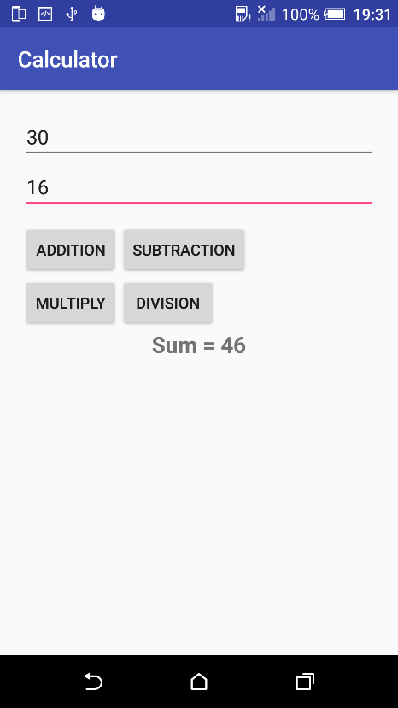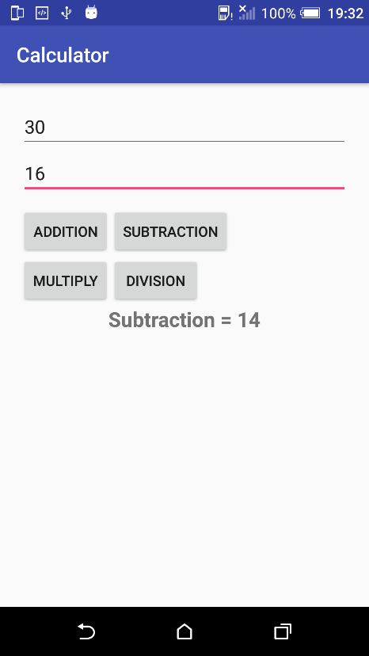

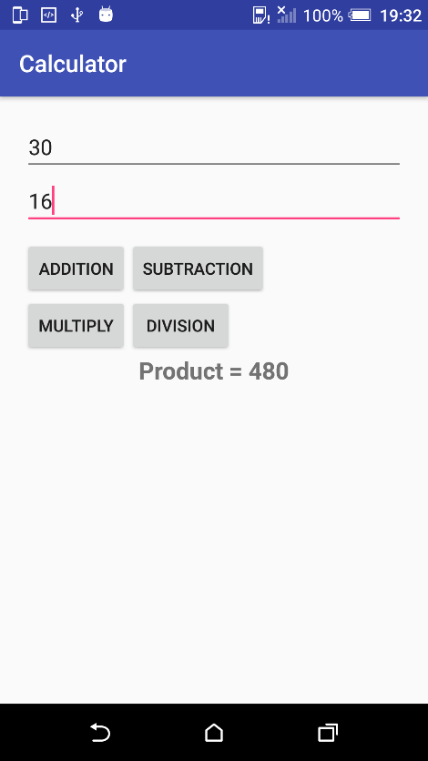 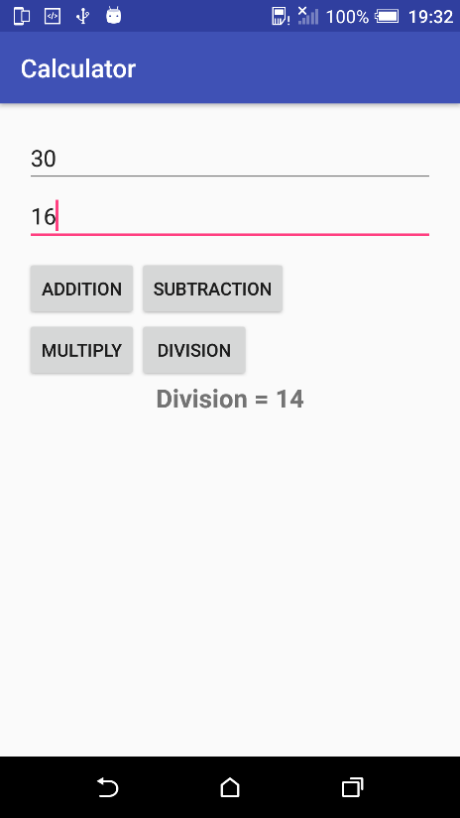

**Practical 4 : Create an application for Unit conversion (Length / Weight / Currency /**

**Temperature)**

**Activity_main.xml**

*<?*xml version="1.0" encoding="utf-8"*?>*<LinearLayout xmlns:android="http://schemas.android.com/apk/res/android"  
 xmlns:app="http://schemas.android.com/apk/res-auto"  
 xmlns:tools="http://schemas.android.com/tools"  
 android:layout_width="match_parent"  
 android:layout_height="match_parent"  
 android:orientation="vertical"  
 android:padding="20dp"  
 android:gravity="center"  
 tools:context=".MainActivity">  
  
 <Button  
 android:id="@+id/lengthConverterButton"  
 android:layout_width="wrap_content"  
 android:layout_height="wrap_content"  
 android:text="Length Conveter"/>  
  
 <Button  
 android:id="@+id/weightConverterButton"  
 android:layout_width="wrap_content"  
 android:layout_height="wrap_content"  
 android:text="Weigth Conveter"/>  
  
 <Button  
 android:id="@+id/currencyConverterButton"  
 android:layout_width="wrap_content"  
 android:layout_height="wrap_content"  
 android:text="Currency Conveter"/>  
  
 <Button  
 android:id="@+id/temperatureConverterButton"  
 android:layout_width="wrap_content"  
 android:layout_height="wrap_content"  
 android:text="Temperature Conveter"/>  
  
</LinearLayout>

**MainActivity.java**

package converter.com.converter;  
  
import android.content.Intent;  
import android.os.Bundle;  
import android.support.v7.app.AppCompatActivity;  
import android.view.View;  
import android.widget.Button;  
public class MainActivity extends AppCompatActivity {  
  
 private Button lengthConverterButton;  
 private Button weightConverterButton;  
 private Button currencyConverterButton;  
 private Button temperatureConverterButton;  
  
 @Override  
 protected void onCreate(Bundle savedInstanceState) {  
 super.onCreate(savedInstanceState);  
 setContentView(R.layout.*activity_main*);  
  
 lengthConverterButton = findViewById(R.id.*lengthConverterButton*);  
 weightConverterButton = findViewById(R.id.*weightConverterButton*);  
 currencyConverterButton = findViewById(R.id.*currencyConverterButton*);  
 temperatureConverterButton = findViewById(R.id.*temperatureConverterButton*);  
  
 lengthConverterButton.setOnClickListener(new View.OnClickListener() {  
 @Override  
 public void onClick(View view) {  
 Intent intent = new Intent(MainActivity.this,LengthConverterActivity.class);  
 startActivity(intent);  
 }  
 });  
  
 weightConverterButton.setOnClickListener(new View.OnClickListener() {  
 @Override  
 public void onClick(View view) {  
 Intent intent = new Intent(MainActivity.this,WeightConverterLengthConverterActivity.class);  
 startActivity(intent);  
 }  
 });  
  
 currencyConverterButton.setOnClickListener(new View.OnClickListener() {  
 @Override  
 public void onClick(View view) {  
 Intent intent = new Intent(MainActivity.this,CurrencyConverterActivity.class);  
 startActivity(intent);  
 }  
 });  
  
 temperatureConverterButton.setOnClickListener(new View.OnClickListener() {  
 @Override  
 public void onClick(View view) {  
 Intent intent = new Intent(MainActivity.this,TemperatureConverterLengthConverterActivity.class);  
 startActivity(intent);  
 }  
 });  
 }  
}

**Activity_length.xml**

*<?*xml version="1.0" encoding="utf-8"*?>*<LinearLayout xmlns:android="http://schemas.android.com/apk/res/android"  
 android:orientation="vertical"  
 android:layout_width="match_parent"  
 android:layout_height="match_parent"  
 android:padding="20dp">  
  
 <EditText  
 android:id="@+id/metersEditText"  
 android:layout_width="match_parent"  
 android:layout_height="wrap_content"  
 android:hint="Enter length in meters"/>  
  
 <Button  
 android:id="@+id/kilometersButton"  
 android:layout_width="wrap_content"  
 android:layout_height="wrap_content"  
 android:text="Convert to KM"  
 android:layout_marginTop="16dp"/>  
  
 <TextView  
 android:id="@+id/resultkmTextView"  
 android:layout_width="match_parent"  
 android:layout_height="wrap_content"  
 android:visibility="gone"  
 android:layout_marginTop="16dp"  
 android:textSize="15sp"  
 android:textStyle="bold"  
 android:textColor="#000"/>  
  
 <Button  
 android:id="@+id/centimetersButton"  
 android:layout_width="wrap_content"  
 android:layout_height="wrap_content"  
 android:text="Convert to CM"  
 android:layout_marginTop="16dp"/>  
  
 <TextView  
 android:id="@+id/resultcmTextView"  
 android:layout_width="match_parent"  
 android:layout_height="wrap_content"  
 android:visibility="gone"  
 android:layout_marginTop="16dp"  
 android:textSize="15sp"  
 android:textStyle="bold"  
 android:textColor="#000"/>  
  
 <Button  
 android:id="@+id/inchButton"  
 android:layout_width="wrap_content"  
 android:layout_height="wrap_content"  
 android:text="Convert to Inches"  
 android:layout_marginTop="16dp"/>  
  
 <TextView  
 android:id="@+id/resultinchesTextView"  
 android:layout_width="match_parent"  
 android:layout_height="wrap_content"  
 android:visibility="gone"  
 android:layout_marginTop="16dp"  
 android:textSize="15sp"  
 android:textStyle="bold"  
 android:textColor="#000"/>  
  
  
</LinearLayout>

**LengthConverter.java**

package converter.com.converter;  
import android.os.Bundle;  
import android.support.v7.app.AppCompatActivity;  
import android.view.View;  
import android.widget.Button;  
import android.widget.EditText;  
import android.widget.TextView;  
  
public class LengthConverterActivity extends AppCompatActivity {  
  
 private EditText metersEditText;  
 private Button kilometersButton;  
 private Button centimetersButton;  
 private Button inchButton;  
 private TextView resultkmTextView;  
 private TextView resultcmTextView;  
 private TextView resultinchesTextView;  
  
 @Override  
 protected void onCreate(Bundle savedInstanceState) {  
 super.onCreate(savedInstanceState);  
 setContentView(R.layout.*activity_length*);  
  
 metersEditText = findViewById(R.id.*metersEditText*);  
 kilometersButton = findViewById(R.id.*kilometersButton*);  
 centimetersButton = findViewById(R.id.*centimetersButton*);  
 inchButton = findViewById(R.id.*inchButton*);  
 resultkmTextView = findViewById(R.id.*resultkmTextView*);  
 resultcmTextView = findViewById(R.id.*resultcmTextView*);  
 resultinchesTextView = findViewById(R.id.*resultinchesTextView*);  
  
 kilometersButton.setOnClickListener(new View.OnClickListener() {  
 @Override  
 public void onClick(View view) {  
 int meters = Integer.*parseInt*(metersEditText.getText().toString());  
 double km = meters * 0.001;  
 resultkmTextView.setVisibility(View.*VISIBLE*);  
 resultkmTextView.setText(meters +" meters to KM = " +km);  
 }  
 });  
  
 centimetersButton.setOnClickListener(new View.OnClickListener() {  
 @Override  
 public void onClick(View view) {  
 int meters = Integer.*parseInt*(metersEditText.getText().toString());  
 double cm = meters * 100;  
 resultcmTextView.setVisibility(View.*VISIBLE*);  
 resultcmTextView.setText(meters +" meters to CM = " +cm);  
 }  
 });  
  
 inchButton.setOnClickListener(new View.OnClickListener() {  
 @Override  
 public void onClick(View view) {  
 int meters = Integer.*parseInt*(metersEditText.getText().toString());  
 double inches = meters * 39.3701;  
 resultinchesTextView.setVisibility(View.*VISIBLE*);  
 resultinchesTextView.setText(meters +" meters to KM = " +inches);  
 }  
 });  
 }  
}

**Activity_weight.xml**

*<?*xml version="1.0" encoding="utf-8"*?>*<LinearLayout xmlns:android="http://schemas.android.com/apk/res/android"  
 android:orientation="vertical"  
 android:layout_width="match_parent"  
 android:layout_height="match_parent"  
 android:padding="20dp">  
  
 <EditText  
 android:id="@+id/gramsEditText"  
 android:layout_width="match_parent"  
 android:layout_height="wrap_content"  
 android:hint="Enter weight in grams"/>  
  
 <Button  
 android:id="@+id/kgButton"  
 android:layout_width="wrap_content"  
 android:layout_height="wrap_content"  
 android:text="Convert to KG"  
 android:layout_marginTop="16dp"/>  
  
 <TextView  
 android:id="@+id/resultkgTextView"  
 android:layout_width="match_parent"  
 android:layout_height="wrap_content"  
 android:visibility="gone"  
 android:layout_marginTop="16dp"  
 android:textSize="15sp"  
 android:textStyle="bold"  
 android:textColor="#000"/>  
  
 <Button  
 android:id="@+id/poundButton"  
 android:layout_width="wrap_content"  
 android:layout_height="wrap_content"  
 android:text="Convert to Pound"  
 android:layout_marginTop="16dp"/>  
  
 <TextView  
 android:id="@+id/resultpoundTextView"  
 android:layout_width="match_parent"  
 android:layout_height="wrap_content"  
 android:visibility="gone"  
 android:layout_marginTop="16dp"  
 android:textSize="15sp"  
 android:textStyle="bold"  
 android:textColor="#000"/>  
  
 <Button  
 android:id="@+id/tonneButton"  
 android:layout_width="wrap_content"  
 android:layout_height="wrap_content"  
 android:text="Convert to Ounce"  
 android:layout_marginTop="16dp"/>  
  
 <TextView  
 android:id="@+id/resultTonneTextView"  
 android:layout_width="match_parent"  
 android:layout_height="wrap_content"  
 android:visibility="gone"  
 android:layout_marginTop="16dp"  
 android:textSize="15sp"  
 android:textStyle="bold"  
 android:textColor="#000"/>  
  
</LinearLayout>

**WeightConverter.java**

package converter.com.converter;  
import android.os.Bundle;  
import android.support.v7.app.AppCompatActivity;  
import android.view.View;  
import android.widget.Button;  
import android.widget.EditText;  
import android.widget.TextView;  
  
public class WeightConverterLengthConverterActivity extends AppCompatActivity {  
 private EditText gramsEditText;  
 private Button kgButton;  
 private Button poundButton;  
 private Button tonneButton;  
 private TextView resultkgTextView;  
 private TextView resultpoundTextView;  
 private TextView resultTonneTextView;  
  
 @Override  
 protected void onCreate(Bundle savedInstanceState) {  
 super.onCreate(savedInstanceState);  
 setContentView(R.layout.*activity_weight*);  
  
 gramsEditText = findViewById(R.id.*gramsEditText*);  
 kgButton = findViewById(R.id.*kgButton*);  
 poundButton = findViewById(R.id.*poundButton*);  
 tonneButton = findViewById(R.id.*tonneButton*);  
 resultkgTextView = findViewById(R.id.*resultkgTextView*);  
 resultpoundTextView = findViewById(R.id.*resultpoundTextView*);  
 resultTonneTextView = findViewById(R.id.*resultTonneTextView*);  
  
 kgButton.setOnClickListener(new View.OnClickListener() {  
 @Override  
 public void onClick(View view) {  
 int grams = Integer.*parseInt*(gramsEditText.getText().toString());  
 double kg = grams * 0.001;  
 resultkgTextView.setVisibility(View.*VISIBLE*);  
 resultkgTextView.setText(grams +" grams to KM = " +kg);  
 }  
 });  
  
 poundButton.setOnClickListener(new View.OnClickListener() {  
 @Override  
 public void onClick(View view) {  
 int grams = Integer.*parseInt*(gramsEditText.getText().toString());  
 double pound = grams * 0.00220462;  
 resultpoundTextView.setVisibility(View.*VISIBLE*);  
 resultpoundTextView.setText(grams +" grams to pound = " +pound);  
 }  
 });  
  
 tonneButton.setOnClickListener(new View.OnClickListener() {  
 @Override  
 public void onClick(View view) {  
 int grams = Integer.*parseInt*(gramsEditText.getText().toString());  
 double tonne = grams * 9.9999;  
 resultTonneTextView.setVisibility(View.*VISIBLE*);  
 resultTonneTextView.setText(grams +" grams to Ounce = " +tonne);  
 }  
 });  
 }  
}

**Activity_currency.xml**

*<?*xml version="1.0" encoding="utf-8"*?>*<LinearLayout  
 xmlns:android="http://schemas.android.com/apk/res/android"  
 android:orientation="vertical"  
 android:layout_width="match_parent"  
 android:layout_height="match_parent"  
 android:padding="20dp">  
  
 <EditText  
 android:id="@+id/indianEditText"  
 android:layout_width="match_parent"  
 android:layout_height="wrap_content"  
 android:hint="Enter in Indian RS"/>  
  
 <Button  
 android:id="@+id/usdButton"  
 android:layout_width="wrap_content"  
 android:layout_height="wrap_content"  
 android:text="Convert to USD"  
 android:layout_marginTop="16dp"/>  
  
 <TextView  
 android:id="@+id/resultusdTextView"  
 android:layout_width="match_parent"  
 android:layout_height="wrap_content"  
 android:visibility="gone"  
 android:layout_marginTop="16dp"  
 android:textSize="15sp"  
 android:textStyle="bold"  
 android:textColor="#000"/>  
  
 <Button  
 android:id="@+id/poundButton"  
 android:layout_width="wrap_content"  
 android:layout_height="wrap_content"  
 android:text="Convert to Pound"  
 android:layout_marginTop="16dp"/>  
  
 <TextView  
 android:id="@+id/resultpoundTextView"  
 android:layout_width="match_parent"  
 android:layout_height="wrap_content"  
 android:visibility="gone"  
 android:layout_marginTop="16dp"  
 android:textSize="15sp"  
 android:textStyle="bold"  
 android:textColor="#000"/>  
  
 <Button  
 android:id="@+id/yenButton"  
 android:layout_width="wrap_content"  
 android:layout_height="wrap_content"  
 android:text="Convert to Yen"  
 android:layout_marginTop="16dp"/>  
  
 <TextView  
 android:id="@+id/resultyenTextView"  
 android:layout_width="match_parent"  
 android:layout_height="wrap_content"  
 android:visibility="gone"  
 android:layout_marginTop="16dp"  
 android:textSize="15sp"  
 android:textStyle="bold"  
 android:textColor="#000"/>  
  
</LinearLayout>

**CurrencyConverter.java**

package converter.com.converter;  
import android.os.Bundle;  
import android.support.v7.app.AppCompatActivity;  
import android.view.View;  
import android.widget.Button;  
import android.widget.EditText;  
import android.widget.TextView;  
  
public class CurrencyConverterActivity extends AppCompatActivity{  
  
  
 private EditText indianEditText;  
 private Button usdButton;  
 private Button poundButton;  
 private Button yenButton;  
 private TextView resultusdTextView;  
 private TextView resultpoundTextView;  
 private TextView resultyenTextView;  
  
 @Override  
 protected void onCreate(Bundle savedInstanceState) {  
 super.onCreate(savedInstanceState);  
 setContentView(R.layout.*activity_currency*);  
  
 indianEditText = findViewById(R.id.*indianEditText*);  
 usdButton = findViewById(R.id.*usdButton*);  
 poundButton = findViewById(R.id.*poundButton*);  
 yenButton = findViewById(R.id.*yenButton*);  
 resultusdTextView = findViewById(R.id.*resultusdTextView*);  
 resultpoundTextView = findViewById(R.id.*resultpoundTextView*);  
 resultyenTextView = findViewById(R.id.*resultyenTextView*);  
  
 usdButton.setOnClickListener(new View.OnClickListener() {  
 @Override  
 public void onClick(View view) {  
 int rs = Integer.*parseInt*(indianEditText.getText().toString());  
 double usd = rs * 0.015;  
 resultusdTextView.setVisibility(View.*VISIBLE*);  
 resultusdTextView.setText(rs +" RS to USD = " +usd);  
 }  
 });  
  
 poundButton.setOnClickListener(new View.OnClickListener() {  
 @Override  
 public void onClick(View view) {  
 int rs = Integer.*parseInt*(indianEditText.getText().toString());  
 double pound = rs * 0.011;  
 resultpoundTextView.setVisibility(View.*VISIBLE*);  
 resultpoundTextView.setText(rs +" RS to Pound = " +pound);  
 }  
 });  
  
 yenButton.setOnClickListener(new View.OnClickListener() {  
 @Override  
 public void onClick(View view) {  
 int rs = Integer.*parseInt*(indianEditText.getText().toString());  
 double yen = rs * 1.61;  
 resultyenTextView.setVisibility(View.*VISIBLE*);  
 resultyenTextView.setText(rs +" RS to Yen = " +yen);  
 }  
 });  
  
 }  
}

**Activity_temperature.xml**

*<?*xml version="1.0" encoding="utf-8"*?>*<LinearLayout xmlns:android="http://schemas.android.com/apk/res/android"  
 android:orientation="vertical"  
 android:layout_width="match_parent"  
 android:layout_height="match_parent"  
 android:padding="20dp">  
  
 <EditText  
 android:id="@+id/celciusEditText"  
 android:layout_width="match_parent"  
 android:layout_height="wrap_content"  
 android:hint="Enter temperature in Celcius"/>  
  
 <Button  
 android:id="@+id/fahrenheitButton"  
 android:layout_width="wrap_content"  
 android:layout_height="wrap_content"  
 android:text="Convert to Fahrenheit"  
 android:layout_marginTop="16dp"/>  
  
 <TextView  
 android:id="@+id/resultfahrenheitTextView"  
 android:layout_width="match_parent"  
 android:layout_height="wrap_content"  
 android:visibility="gone"  
 android:layout_marginTop="16dp"  
 android:textSize="15sp"  
 android:textStyle="bold"  
 android:textColor="#000"/>  
  
 <Button  
 android:id="@+id/kelvinButton"  
 android:layout_width="wrap_content"  
 android:layout_height="wrap_content"  
 android:text="Convert to Kelvin"  
 android:layout_marginTop="16dp"/>  
  
 <TextView  
 android:id="@+id/resultkelvinTextView"  
 android:layout_width="match_parent"  
 android:layout_height="wrap_content"  
 android:visibility="gone"  
 android:layout_marginTop="16dp"  
 android:textSize="15sp"  
 android:textStyle="bold"  
 android:textColor="#000"/>  
  
</LinearLayout>

**TemperatureConverter.java**

package converter.com.converter;  
import android.os.Bundle;  
import android.support.v7.app.AppCompatActivity;  
import android.view.View;  
import android.widget.Button;  
import android.widget.EditText;  
import android.widget.TextView;  
  
public class TemperatureConverterLengthConverterActivity extends AppCompatActivity {  
  
 private EditText celciusEditText;  
 private Button fahrenheitButton;  
 private Button kelvinButton;  
 private TextView resultfahrenheitTextView;  
 private TextView resultkelvinTextView;  
  
 @Override  
 protected void onCreate(Bundle savedInstanceState) {  
 super.onCreate(savedInstanceState);  
 setContentView(R.layout.*activity_temperature*);  
  
 celciusEditText = findViewById(R.id.*celciusEditText*);  
 fahrenheitButton = findViewById(R.id.*fahrenheitButton*);  
 kelvinButton = findViewById(R.id.*kelvinButton*);  
 resultfahrenheitTextView = findViewById(R.id.*resultfahrenheitTextView*);  
 resultkelvinTextView = findViewById(R.id.*resultkelvinTextView*);  
  
 fahrenheitButton.setOnClickListener(new View.OnClickListener() {  
 @Override  
 public void onClick(View view) {  
 int celcius = Integer.*parseInt*(celciusEditText.getText().toString());  
 double fah = celcius * 32;  
 resultfahrenheitTextView.setVisibility(View.*VISIBLE*);  
 resultfahrenheitTextView.setText(celcius +" celcius to fahrenheit = " +fah);  
 }  
 });  
  
 kelvinButton.setOnClickListener(new View.OnClickListener() {  
 @Override  
 public void onClick(View view) {  
 int celcius = Integer.*parseInt*(celciusEditText.getText().toString());  
 double kelvin = celcius * 273.15;  
 resultkelvinTextView.setVisibility(View.*VISIBLE*);  
 resultkelvinTextView.setText(celcius +" celcius to kelvin = " +kelvin);  
 }  
 });  
  
 }  
}

**Output:**

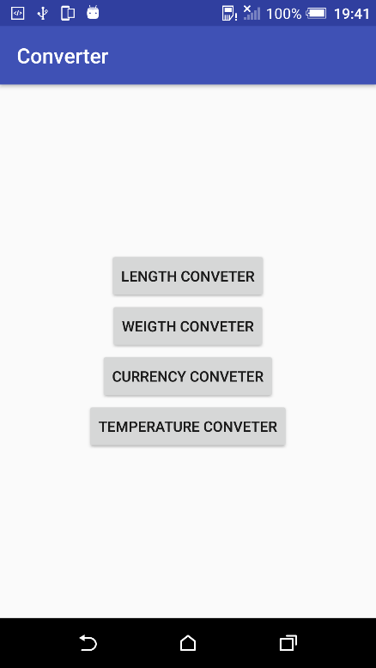 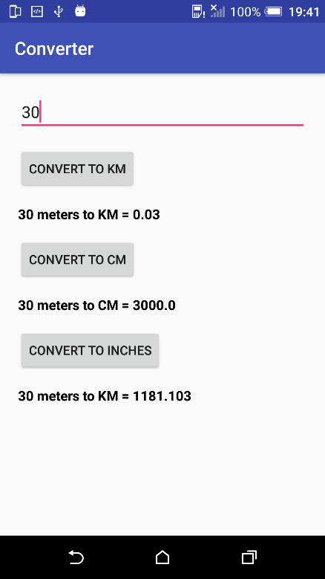 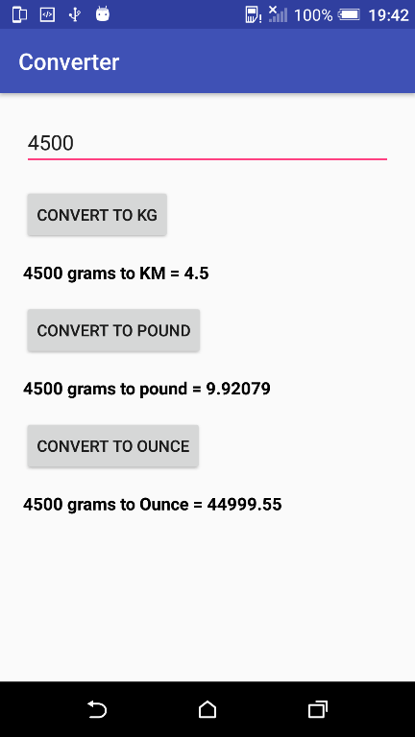

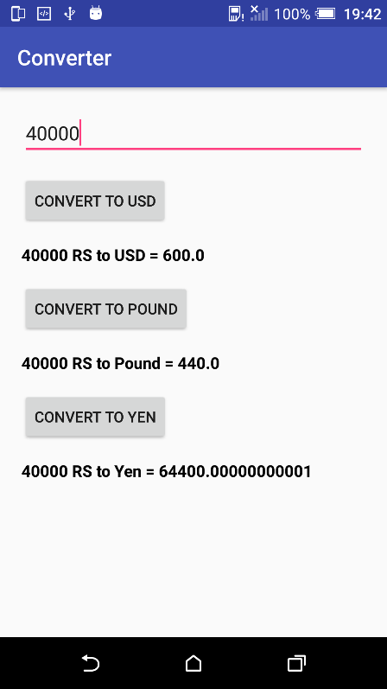 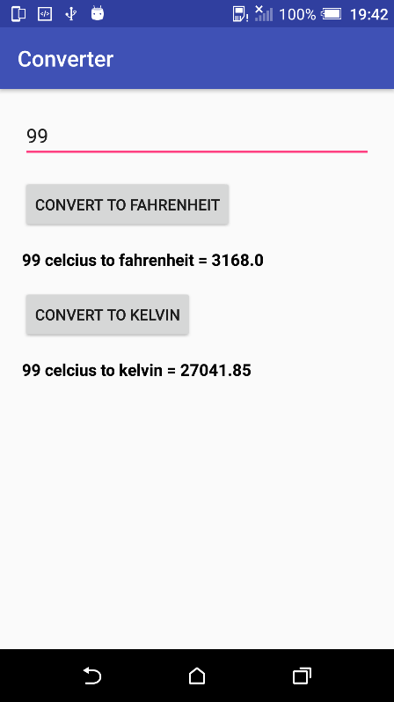

**Practical 5 : Create an activity to implement following UI Components. EditText, TextView, RadioButton, CheckBox, RatingBar. On click of submit button, Read the values for above components programmatically and display them in next activity.**

**Activity_main.xml**

*<?*xml version="1.0" encoding="utf-8"*?>*<RelativeLayout xmlns:android="http://schemas.android.com/apk/res/android"  
 xmlns:app="http://schemas.android.com/apk/res-auto"  
 xmlns:tools="http://schemas.android.com/tools"  
 android:layout_width="match_parent"  
 android:layout_height="match_parent"  
 android:padding="20dp"  
 tools:context=".MainActivity">  
  
 <EditText  
 android:id="@+id/nameEditText"  
 android:layout_width="match_parent"  
 android:layout_height="wrap_content"  
 android:hint="Enter the full name"  
 android:textSize="18sp"/>  
  
 <TextView  
 android:id="@+id/genderTextView"  
 android:layout_width="wrap_content"  
 android:layout_height="wrap_content"  
 android:text="Gender : "  
 android:textSize="18sp"  
 android:layout_marginTop="12dp"  
 android:layout_below="@id/nameEditText"/>  
 <RadioGroup  
 android:id="@+id/genderRadioGroup"  
 android:layout_width="match_parent"  
 android:layout_height="wrap_content"  
 android:orientation="horizontal"  
 android:layout_below="@id/nameEditText"  
 android:layout_marginTop="6dp"  
 android:layout_toRightOf="@id/genderTextView">  
  
 <RadioButton  
 android:id="@+id/maleRadioButton"  
 android:layout_width="wrap_content"  
 android:layout_height="wrap_content"  
 android:text="Male"  
 android:textSize="18sp"/>  
  
 <RadioButton  
 android:id="@+id/femaleRadioButton"  
 android:layout_width="wrap_content"  
 android:layout_height="wrap_content"  
 android:text="Female"  
 android:textSize="18sp"/>  
 </RadioGroup>  
 <EditText  
 android:id="@+id/salaryEditText"  
 android:layout_width="match_parent"  
 android:layout_height="wrap_content"  
 android:hint="Enter the salary"  
 android:layout_marginTop="12dp"  
 android:textSize="18sp"  
 android:layout_below="@id/genderRadioGroup"/>  
  
 <CheckedTextView  
 android:id="@+id/languagesChecboxTextView"  
 android:layout_width="wrap_content"  
 android:layout_height="wrap_content"  
 android:text="Select Languages : "  
 android:layout_marginTop="12dp"  
 android:textSize="18sp"  
 android:layout_below="@id/salaryEditText"/>  
  
 <CheckBox  
 android:id="@+id/angularCheckBox"  
 android:layout_width="wrap_content"  
 android:layout_height="wrap_content"  
 android:text="Angular JS"  
 android:textSize="18sp"  
 android:layout_below="@id/languagesChecboxTextView"/>  
  
 <CheckBox  
 android:id="@+id/bootstrapCheckBox"  
 android:layout_width="wrap_content"  
 android:layout_height="wrap_content"  
 android:text="BootStrap"  
 android:textSize="18sp"  
 android:layout_below="@id/languagesChecboxTextView"  
 android:layout_toRightOf="@id/angularCheckBox"/>  
  
 <CheckBox  
 android:id="@+id/nodeJsCheckBox"  
 android:layout_width="wrap_content"  
 android:layout_height="wrap_content"  
 android:text="Node JS"  
 android:textSize="18sp"  
 android:layout_below="@id/angularCheckBox"/>  
  
 <CheckBox  
 android:id="@+id/androidCheckBox"  
 android:layout_width="wrap_content"  
 android:layout_height="wrap_content"  
 android:text="Android"  
 android:textSize="18sp"  
 android:layout_below="@id/angularCheckBox"  
 android:layout_toRightOf="@id/nodeJsCheckBox"/>  
  
 <RatingBar  
 android:id="@+id/ratingBar"  
 android:layout_width="wrap_content"  
 android:layout_height="wrap_content"  
 android:layout_below="@id/nodeJsCheckBox"  
 android:layout_marginTop="12dp"  
 android:textSize="18sp"  
 android:stepSize="1.0"/>  
  
 <Button  
 android:id="@+id/submitButton"  
 android:layout_width="wrap_content"  
 android:layout_height="wrap_content"  
 android:text="Submit"  
 android:layout_marginTop="12dp"  
 android:layout_below="@id/ratingBar"  
 android:gravity="center"/>  
  
  
</RelativeLayout>

**MainActivity.java**

package bundle.com.bundleimplementation;  
import android.content.Intent;  
import android.os.Bundle;  
import android.support.v7.app.AppCompatActivity;  
import android.view.View;  
import android.widget.Button;  
import android.widget.CheckBox;  
import android.widget.EditText;  
import android.widget.RadioButton;  
import android.widget.RadioGroup;  
import android.widget.RatingBar;  
public class MainActivity extends AppCompatActivity {  
 private EditText nameEditText;  
 private RadioGroup genderRadioGroup;  
 private RadioButton genderButton;  
 private EditText salaryEditText;  
 private CheckBox angularCheckBox;  
 private CheckBox bootstrapCheckBox;  
 private CheckBox nodeJsCheckBox;  
 private CheckBox androidCheckBox;  
 private RatingBar ratingBar;  
 private Button submitButton;  
 @Override  
 protected void onCreate(Bundle savedInstanceState) {  
 super.onCreate(savedInstanceState);  
 setContentView(R.layout.*activity_main*);  
 nameEditText = findViewById(R.id.*nameEditText*);  
 genderRadioGroup = findViewById(R.id.*genderRadioGroup*);  
 salaryEditText = findViewById(R.id.*salaryEditText*);  
 angularCheckBox = findViewById(R.id.*angularCheckBox*);  
 bootstrapCheckBox = findViewById(R.id.*bootstrapCheckBox*);  
 nodeJsCheckBox = findViewById(R.id.*nodeJsCheckBox*);  
 androidCheckBox = findViewById(R.id.*androidCheckBox*);  
 ratingBar = findViewById(R.id.*ratingBar*);  
 submitButton = findViewById(R.id.*submitButton*);  
  
 submitButton.setOnClickListener(new View.OnClickListener() {  
 @Override  
 public void onClick(View view) {  
 String name = nameEditText.getText().toString();  
 int genderId = genderRadioGroup.getCheckedRadioButtonId();  
 genderButton = findViewById(genderId);  
 String gender = genderButton.getText().toString();  
 int salary = Integer.*parseInt*(salaryEditText.getText().toString());  
 double tax = 0;  
 if(salary > 20000 && salary < 50000){  
 tax = 0.12 * salary;  
 }else if(salary > 50001){  
 tax = 0.18 * salary;  
 }  
 float rating = ratingBar.getRating();  
 Bundle bundle = new Bundle();  
 bundle.putString("Name", name);  
 bundle.putString("Gender", gender);  
 bundle.putInt("Salary",salary);  
 bundle.putDouble("Tax",tax);  
 if(angularCheckBox.isChecked()){  
 bundle.putString("AngularJS",angularCheckBox.getText().toString());  
 }  
 if(bootstrapCheckBox.isChecked()){  
 bundle.putString("Bootstrap","Bootstrap");  
 }  
 if(nodeJsCheckBox.isChecked()){  
 bundle.putString("NodeJS","Node JS");  
 }  
 if(androidCheckBox.isChecked()){  
 bundle.putString("Android","Android");  
 }  
 bundle.putFloat("Rating",rating);  
 Intent intent = new Intent(MainActivity.this,ShowDetails.class);  
 intent.putExtras(bundle);  
 startActivity(intent);  
  
 }  
 });  
 }  
}

**Activity_display.xml**

*<?*xml version="1.0" encoding="utf-8"*?>*<RelativeLayout  
 xmlns:android="http://schemas.android.com/apk/res/android"  
 android:layout_width="match_parent"  
 android:layout_height="match_parent"  
 android:padding="20dp">  
  
 <TextView  
 android:id="@+id/nameTextView"  
 android:layout_width="match_parent"  
 android:layout_height="wrap_content"  
 android:textSize="20sp"  
 android:textStyle="bold"  
 android:textColor="#000"/>  
  
 <TextView  
 android:id="@+id/genderTextView"  
 android:layout_width="match_parent"  
 android:layout_height="wrap_content"  
 android:textSize="20sp"  
 android:textStyle="bold"  
 android:textColor="#000"  
 android:layout_marginTop="16dp"  
 android:layout_below="@id/nameTextView"/>  
  
 <TextView  
 android:id="@+id/salaryTextView"  
 android:layout_width="match_parent"  
 android:layout_height="wrap_content"  
 android:textSize="20sp"  
 android:textStyle="bold"  
 android:textColor="#000"  
 android:layout_marginTop="16dp"  
 android:layout_below="@id/genderTextView"/>  
  
 <TextView  
 android:id="@+id/taxTextView"  
 android:layout_width="match_parent"  
 android:layout_height="wrap_content"  
 android:textSize="20sp"  
 android:textStyle="bold"  
 android:textColor="#000"  
 android:layout_marginTop="16dp"  
 android:layout_below="@id/salaryTextView"/>  
  
 <TextView  
 android:id="@+id/langugesTextView"  
 android:layout_width="match_parent"  
 android:layout_height="wrap_content"  
 android:textSize="20sp"  
 android:textStyle="bold"  
 android:textColor="#000"  
 android:layout_marginTop="16dp"  
 android:text="Languages Known : "  
 android:layout_below="@id/taxTextView"/>  
  
 <TextView  
 android:id="@+id/angularTextView"  
 android:layout_width="match_parent"  
 android:layout_height="wrap_content"  
 android:textSize="16sp"  
 android:textStyle="bold"  
 android:textColor="#000"  
 android:visibility="gone"  
 android:layout_below="@id/langugesTextView"/>  
  
 <TextView  
 android:id="@+id/bootstrapTextView"  
 android:layout_width="match_parent"  
 android:layout_height="wrap_content"  
 android:textSize="16sp"  
 android:textStyle="bold"  
 android:textColor="#000"  
 android:visibility="gone"  
 android:layout_below="@id/angularTextView"/>  
  
 <TextView  
 android:id="@+id/nodejsTextView"  
 android:layout_width="match_parent"  
 android:layout_height="wrap_content"  
 android:textSize="16sp"  
 android:textStyle="bold"  
 android:textColor="#000"  
 android:visibility="gone"  
 android:layout_below="@id/bootstrapTextView"/>  
  
 <TextView  
 android:id="@+id/androidTextView"  
 android:layout_width="match_parent"  
 android:layout_height="wrap_content"  
 android:textSize="16sp"  
 android:textStyle="bold"  
 android:textColor="#000"  
 android:visibility="gone"  
 android:layout_below="@id/nodejsTextView"/>  
  
 <TextView  
 android:id="@+id/ratingTextView"  
 android:layout_width="match_parent"  
 android:layout_height="wrap_content"  
 android:textSize="20sp"  
 android:textStyle="bold"  
 android:textColor="#000"  
 android:layout_marginTop="16dp"  
 android:layout_below="@id/androidTextView"/>  
  
</RelativeLayout>

**ShowDetails.java**

package bundle.com.bundleimplementation;  
import android.content.Intent;  
import android.os.Bundle;  
import android.support.annotation.Nullable;  
import android.support.v7.app.AppCompatActivity;  
import android.view.View;  
import android.widget.TextView;  
import java.util.ArrayList;  
public class ShowDetails extends AppCompatActivity {  
 private TextView nameTextView;  
 private TextView genderTextView;  
 private TextView salaryTextView;  
 private TextView taxTextView;  
 private TextView ratingTextView;  
 private TextView angularTextView;  
 private TextView bootstrapTextView;  
 private TextView nodejsTextView;  
 private TextView androidTextView;  
  
 private ArrayList<String> languagesKnownList = new ArrayList<String>();  
 private String languages;  
 @Override  
 protected void onCreate(@Nullable Bundle savedInstanceState) {  
 super.onCreate(savedInstanceState);  
 setContentView(R.layout.*activity_display*);  
 nameTextView = findViewById(R.id.*nameTextView*);  
 genderTextView = findViewById(R.id.*genderTextView*);  
 salaryTextView = findViewById(R.id.*salaryTextView*);  
 taxTextView = findViewById(R.id.*taxTextView*);  
 ratingTextView = findViewById(R.id.*ratingTextView*);  
 angularTextView = findViewById(R.id.*angularTextView*);  
 bootstrapTextView = findViewById(R.id.*bootstrapTextView*);  
 nodejsTextView = findViewById(R.id.*nodejsTextView*);  
 androidTextView = findViewById(R.id.*androidTextView*);  
 Intent intent = getIntent();  
 Bundle bundle = intent.getExtras();  
 String name = bundle.getString("Name");  
 String gender = bundle.getString("Gender");  
 int salary = bundle.getInt("Salary");  
 double tax = bundle.getDouble("Tax");  
 float rating = bundle.getFloat("Rating");  
 nameTextView.setText("Name : " +name);  
 genderTextView.setText("Gender : " +gender);  
 salaryTextView.setText("Salary : "+salary);  
 taxTextView.setText("Tax : "+tax);  
 ratingTextView.setText("Ratings : "+rating);  
 String angular = bundle.getString("AngularJS");  
 String bootstrap = bundle.getString("Bootstrap");  
 String nodejs = bundle.getString("NodeJS");  
 String android = bundle.getString("Android");  
 if(angular != null){  
 angularTextView.setVisibility(View.*VISIBLE*);  
 angularTextView.setText(angular);  
 }  
 if(bootstrap != null){  
 bootstrapTextView.setVisibility(View.*VISIBLE*);  
 bootstrapTextView.setText(bootstrap);  
 }  
 if(nodejs != null){  
 nodejsTextView.setVisibility(View.*VISIBLE*);  
 nodejsTextView.setText(nodejs);  
 }  
 if(android != null){  
 androidTextView.setVisibility(View.*VISIBLE*);  
 androidTextView.setText(android);  
 }  
 }  
}

**Output :**

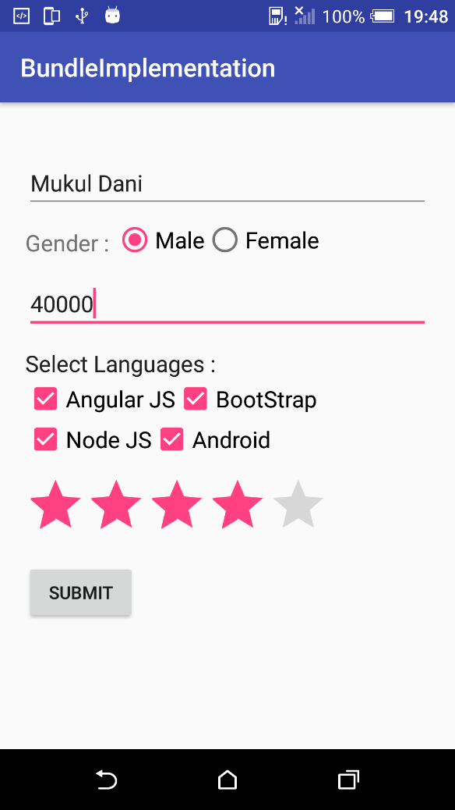 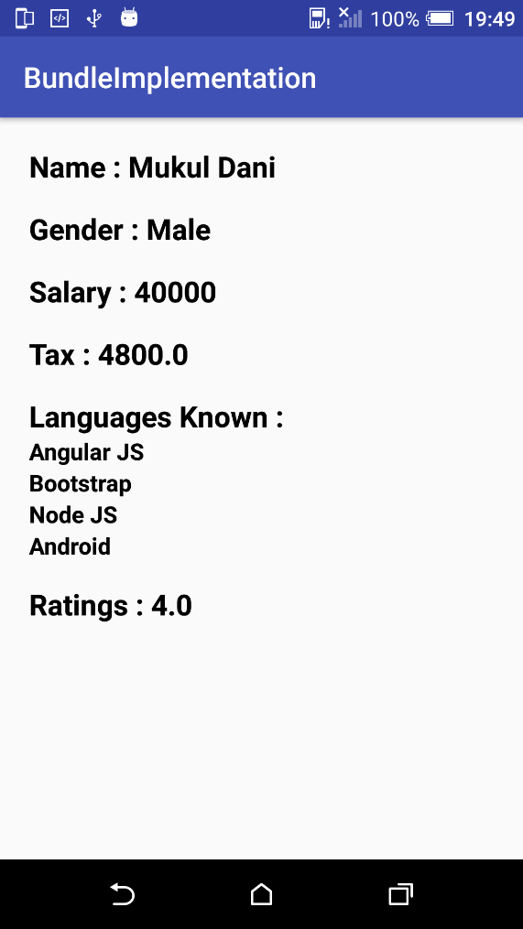

**Practical 6 : Create a login application, on successful login display welcome page and in case of failure display alert box indicating error message and number of attempts made. Disable submit button after 3 wrong attempts and display alert message indicating the same.**

**Activity_main.xml**

*<?*xml version="1.0" encoding="utf-8"*?>*<LinearLayout xmlns:android="http://schemas.android.com/apk/res/android"  
 xmlns:app="http://schemas.android.com/apk/res-auto"  
 xmlns:tools="http://schemas.android.com/tools"  
 android:layout_width="match_parent"  
 android:layout_height="match_parent"  
 android:orientation="vertical"  
 android:padding="20dp"  
 tools:context=".MainActivity">  
  
 <EditText  
 android:id="@+id/usernameEditText"  
 android:layout_width="match_parent"  
 android:layout_height="wrap_content"  
 android:hint="Enter the username"/>  
  
 <EditText  
 android:id="@+id/passwordEditText"  
 android:layout_width="match_parent"  
 android:layout_height="wrap_content"  
 android:password="true"  
 android:hint="Enter the passowrd"/>  
  
 <LinearLayout  
 android:layout_width="match_parent"  
 android:layout_height="match_parent"  
 android:orientation="horizontal"  
 android:layout_gravity="center">  
  
 <Button  
 android:id="@+id/loginButton"  
 android:layout_width="wrap_content"  
 android:layout_height="wrap_content"  
 android:text="Login"/>  
  
 <Button  
 android:id="@+id/clearButton"  
 android:layout_width="wrap_content"  
 android:layout_height="wrap_content"  
 android:text="Clear"/>  
  
 </LinearLayout>  
  
</LinearLayout>

**MainActivity.java**

package attempts.login.com.loginattempts;  
import android.content.Context;  
import android.content.SharedPreferences;  
import android.os.Bundle;  
import android.support.v7.app.AppCompatActivity;  
import android.view.View;  
import android.widget.Button;  
import android.widget.EditText;  
import android.widget.Toast;  
  
public class MainActivity extends AppCompatActivity {  
  
 private EditText usernameEditText;  
 private EditText passwordEditText;  
 private Button loginButton;  
 private Button clearButton;  
 private SharedPreferences sharedPreferences;  
 private final static String *PREF_CREDENTIALS* = "Credentials";  
 private final static String *PREF_KEY_LOGIN_ATTEMPTS* = "Login_Attempts";  
 private int login_attempts;  
  
 @Override  
 protected void onCreate(Bundle savedInstanceState) {  
 super.onCreate(savedInstanceState);  
 setContentView(R.layout.*activity_main*);  
  
 usernameEditText = findViewById(R.id.*usernameEditText*);  
 passwordEditText = findViewById(R.id.*passwordEditText*);  
 loginButton = findViewById(R.id.*loginButton*);  
 clearButton = findViewById(R.id.*clearButton*);  
 sharedPreferences = getSharedPreferences(*PREF_CREDENTIALS*, Context.*MODE_PRIVATE*);  
  
 if(getAttemptCount()){  
 login_attempts = sharedPreferences.getInt(*PREF_KEY_LOGIN_ATTEMPTS*, 0);  
 }  
  
 loginButton.setOnClickListener(new View.OnClickListener() {  
 @Override  
 public void onClick(View view) {  
 login();  
 }  
 });  
  
 clearButton.setOnClickListener(new View.OnClickListener() {  
 @Override  
 public void onClick(View view) {  
 sharedPreferences.edit().clear().apply();  
 loginButton.setEnabled(true);  
 }  
 });  
 }  
 private void login() {  
 String username = usernameEditText.getText().toString();  
 String password = passwordEditText.getText().toString();  
 if(username.equals("mukul@gmail.com") && password.equals("mukul")){  
 Toast.*makeText*(this, "Welcome", Toast.*LENGTH_SHORT*).show();  
 }else{  
 if(login_attempts == 3){  
 Toast.*makeText*(this,"All attempts done", Toast.*LENGTH_LONG*).show();  
 loginButton.setEnabled(false);  
 }else{  
 login_attempts += 1;  
 Toast.*makeText*(this,"Login Failed. Attempt - "+login_attempts, Toast.*LENGTH_LONG*).show();  
 }  
 }  
 }  
  
 private boolean getAttemptCount(){  
 return sharedPreferences.contains(*PREF_KEY_LOGIN_ATTEMPTS*);  
 }  
}

**Output:**

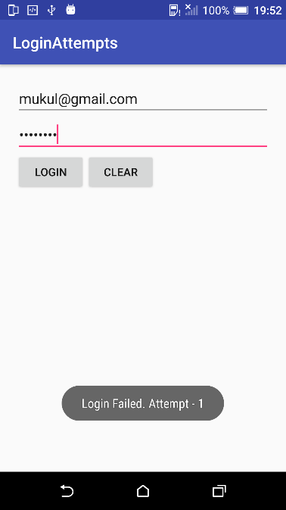 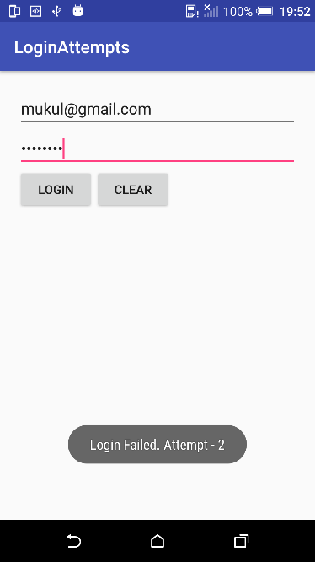 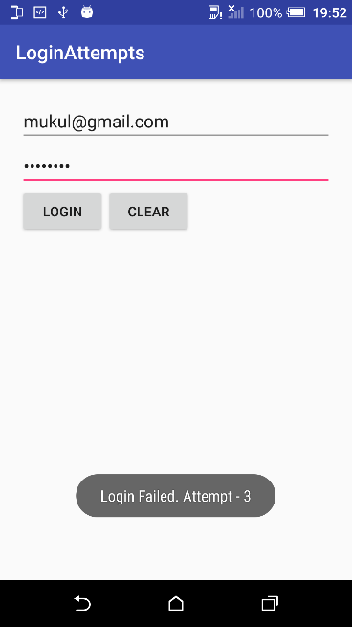

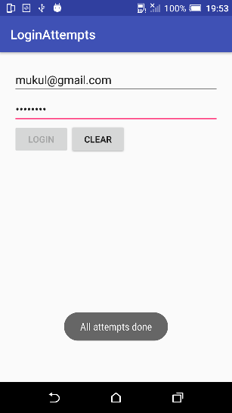 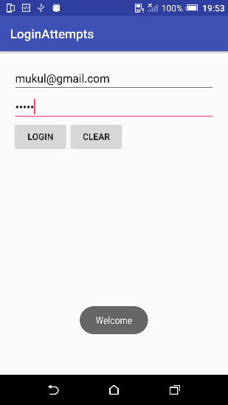

**Practical 7 : Create a login application which will ask user to provide username and password, once user enters username and password display welcome or failure message as per the validation rule. Also provide remember me checkbox, which can save username and password in Shared Preference if checked. Next time when user launches the application, auto fill username and password fields if they are present in Shared Preference.**

**Activity_main.xml**

*<?*xml version="1.0" encoding="utf-8"*?>*<LinearLayout xmlns:android="http://schemas.android.com/apk/res/android"  
 xmlns:app="http://schemas.android.com/apk/res-auto"  
 xmlns:tools="http://schemas.android.com/tools"  
 android:layout_width="match_parent"  
 android:layout_height="match_parent"  
 android:orientation="vertical"  
 android:padding="20dp"  
 tools:context=".MainActivity">  
  
 <EditText  
 android:id="@+id/usernameEditText"  
 android:layout_width="match_parent"  
 android:layout_height="wrap_content"  
 android:hint="Enter the username"/>  
  
 <EditText  
 android:id="@+id/passwordEditText"  
 android:layout_width="match_parent"  
 android:layout_height="wrap_content"

android:inputType="textPassword"  
 android:hint="Enter the password"/>  
  
 <CheckBox  
 android:id="@+id/remmbermeCheckBox"  
 android:layout_width="match_parent"  
 android:layout_height="wrap_content"  
 android:text="Remember Me"/>  
  
 <LinearLayout  
 android:layout_width="match_parent"  
 android:layout_height="match_parent"  
 android:orientation="horizontal">  
  
 <Button  
 android:id="@+id/loginButton"  
 android:layout_width="wrap_content"  
 android:layout_height="wrap_content"  
 android:text="Login"/>  
  
 <Button  
 android:id="@+id/clearButton"  
 android:layout_width="wrap_content"  
 android:layout_height="wrap_content"  
 android:text="Clear"/>  
  
  
 </LinearLayout>  
  
</LinearLayout>

**MainActivity.java**

package savedetails.login.com.login;  
import android.content.Context;  
import android.content.SharedPreferences;  
import android.support.v7.app.AppCompatActivity;  
import android.os.Bundle;  
import android.view.View;  
import android.widget.Button;  
import android.widget.CheckBox;  
import android.widget.EditText;  
import android.widget.Toast;  
public class MainActivity extends AppCompatActivity {  
 private EditText usernameEditText;  
 private EditText passwordEditText;  
 private Button loginButton;  
 private Button clearButton;  
 private CheckBox remmbermeCheckBox;  
 private SharedPreferences sharedPreferences;  
 private final static String *PREF_CREDENTIALS* = "Credentials";  
 private final static String *PREF_KEY_USERNAME* = "Username";  
 private final static String *PREF_KEY_PASSWORD* = "Password";  
  
 @Override  
 protected void onCreate(Bundle savedInstanceState) {  
 super.onCreate(savedInstanceState);  
 setContentView(R.layout.*activity_main*);  
 usernameEditText = findViewById(R.id.*usernameEditText*);  
 passwordEditText = findViewById(R.id.*passwordEditText*);  
 loginButton = findViewById(R.id.*loginButton*);  
 clearButton = findViewById(R.id.*clearButton*);  
 remmbermeCheckBox = findViewById(R.id.*remmbermeCheckBox*);  
 sharedPreferences = getSharedPreferences(*PREF_CREDENTIALS*, Context.*MODE_PRIVATE*);  
 if(isAlreadyLogedIn()){  
 String username = sharedPreferences.getString(*PREF_KEY_USERNAME*,"");  
 String password = sharedPreferences.getString(*PREF_KEY_PASSWORD*,"");  
 usernameEditText.setText(username);  
 passwordEditText.setText(password);  
 }  
  
 loginButton.setOnClickListener(new View.OnClickListener() {  
 @Override  
 public void onClick(View view) {  
 String username = usernameEditText.getText().toString();  
 String password = passwordEditText.getText().toString();  
 if(username.equals("mukul@gmail.com") && password.equals("mukul1206")){  
 if(remmbermeCheckBox.isChecked()){  
 sharedPreferences.edit().putString(*PREF_KEY_USERNAME*,username).apply();  
 sharedPreferences.edit().putString(*PREF_KEY_PASSWORD*,password).apply();  
 }  
 Toast.*makeText*(MainActivity.this,"Welcome",Toast.*LENGTH_SHORT*).show();  
 }else{  
 Toast.*makeText*(MainActivity.this,"Login Failed",Toast.*LENGTH_SHORT*).show();  
 }  
 }  
 });  
  
 clearButton.setOnClickListener(new View.OnClickListener() {  
 @Override  
 public void onClick(View view) {  
 sharedPreferences.edit().clear().apply();  
 usernameEditText.setText("");  
 passwordEditText.setText("");  
 }  
 });  
  
 }  
  
 private boolean isAlreadyLogedIn() {  
 return sharedPreferences.contains(*PREF_KEY_USERNAME*) && sharedPreferences.contains(*PREF_KEY_PASSWORD*);  
 }  
}

**Output:**

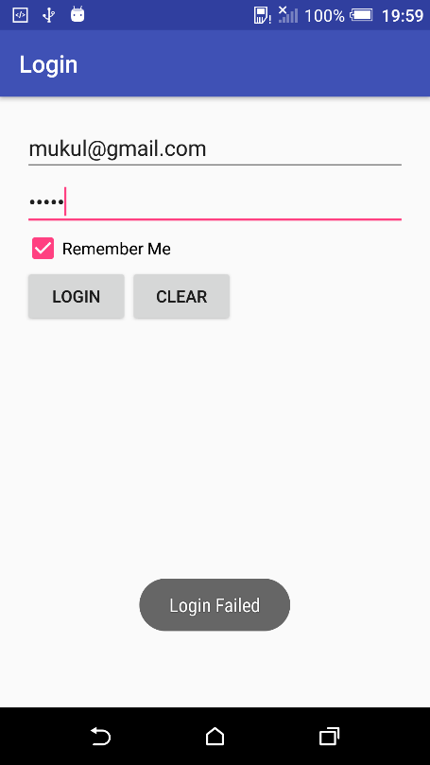 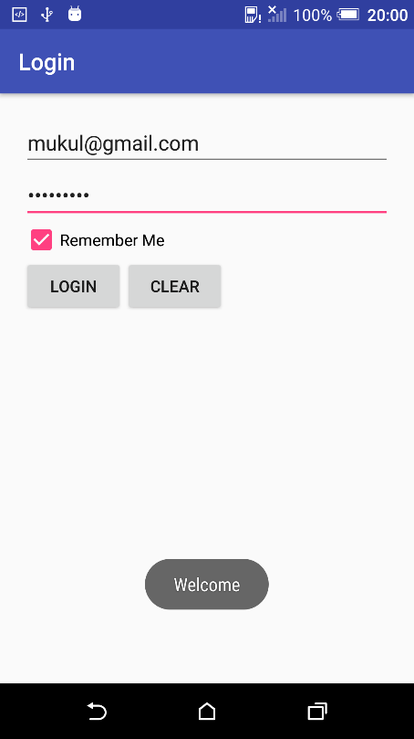 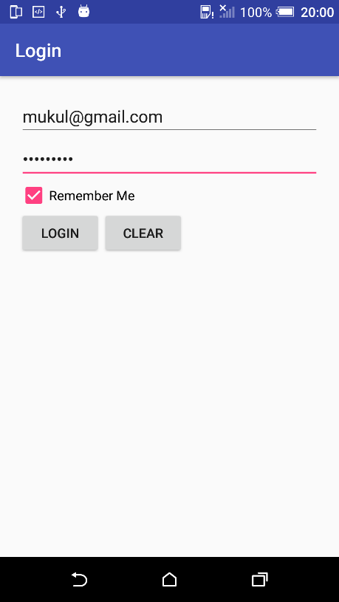

**Practical 8 : Write a program to display Image using ImageView. Put any image in drawable folder and load it inside ImageView. Provide following four animation buttons.**

**1) Alpha Animation - Animate the alpha property of ImageView**

**2) Rotate Animation - Rotate image view from 0 – 360 degree and vice versa**

**3) Translate Animation - animate the location change of ImageView**

**4) Scale Animation – Animate the scaling property of ImageView**

**Activity_main.xml**

*<?*xml version="1.0" encoding="utf-8"*?>*<LinearLayout xmlns:android="http://schemas.android.com/apk/res/android"  
 xmlns:app="http://schemas.android.com/apk/res-auto"  
 xmlns:tools="http://schemas.android.com/tools"  
 android:layout_width="match_parent"  
 android:layout_height="match_parent"  
 android:orientation="vertical"  
 android:padding="10dp"  
 tools:context=".MainActivity">  
  
 <ImageView  
 android:id="@+id/imageView"  
 android:layout_width="match_parent"  
 android:layout_height="wrap_content"  
 android:src="@drawable/i3"  
 android:scaleType="fitCenter"/>  
  
 <LinearLayout  
 android:layout_width="match_parent"  
 android:layout_height="wrap_content"  
 android:orientation="horizontal"  
 android:weightSum="2"  
 android:layout_marginTop="30dp">  
  
 <Button  
 android:id="@+id/alphaButton"  
 android:layout_width="wrap_content"  
 android:layout_height="wrap_content"  
 android:text="Alpha"  
 android:layout_weight="1"/>  
  
 <Button  
 android:id="@+id/rotateButton"  
 android:layout_width="wrap_content"  
 android:layout_height="wrap_content"  
 android:text="Rotate"  
 android:layout_weight="1"/>  
  
 </LinearLayout>  
  
 <LinearLayout  
 android:layout_width="match_parent"  
 android:layout_height="wrap_content"  
 android:orientation="horizontal"  
 android:weightSum="2"  
 android:layout_marginTop="10dp">  
  
 <Button  
 android:id="@+id/translateButton"  
 android:layout_width="wrap_content"  
 android:layout_height="wrap_content"  
 android:text="Translate"  
 android:layout_weight="1"/>  
  
 <Button  
 android:id="@+id/scaleButton"  
 android:layout_width="wrap_content"  
 android:layout_height="wrap_content"  
 android:text="Scale"  
 android:layout_weight="1"/>  
  
 </LinearLayout>  
  
</LinearLayout>

**MainActivity.java**

package animation.imageview.com.imageviewanimation;  
import android.animation.AnimatorSet;  
import android.animation.ObjectAnimator;  
import android.animation.ValueAnimator;  
import android.os.Bundle;  
import android.support.v7.app.AppCompatActivity;  
import android.view.View;  
import android.widget.Button;  
import android.widget.ImageView;  
  
public class MainActivity extends AppCompatActivity implements View.OnClickListener {  
  
 private ImageView imageView;  
 private Button alphaButton;  
 private Button rotateButton;  
 private Button translateButton;  
 private Button scaleButton;  
  
 @Override  
 protected void onCreate(Bundle savedInstanceState) {  
 super.onCreate(savedInstanceState);  
 setContentView(R.layout.*activity_main*);  
  
 imageView = findViewById(R.id.*imageView*);  
 alphaButton = findViewById(R.id.*alphaButton*);  
 rotateButton = findViewById(R.id.*rotateButton*);  
 translateButton = findViewById(R.id.*translateButton*);  
 scaleButton = findViewById(R.id.*scaleButton*);  
  
 alphaButton.setOnClickListener(this);  
 rotateButton.setOnClickListener(this);  
 translateButton.setOnClickListener(this);  
 scaleButton.setOnClickListener(this);  
  
 }  
  
 @Override  
 public void onClick(View view) {  
 switch (view.getId()){  
 case R.id.alphaButton : alphaAnimation();  
 break;  
 case R.id.rotateButton : rotateAnimation();  
 break;  
 case R.id.translateButton : translateAnimation();  
 break;  
 case R.id.scaleButton : scaleAnimation();  
 break;  
 }  
 }  
 private void alphaAnimation() {  
 ObjectAnimator objectAnimator = ObjectAnimator.ofFloat(imageView, View.ALPHA,1,0);  
 objectAnimator.setDuration(4000);  
 objectAnimator.setRepeatCount(ValueAnimator.INFINITE);  
 objectAnimator.setRepeatMode(ValueAnimator.REVERSE);  
 objectAnimator.start();  
 }  
 private void rotateAnimation() {  
 ObjectAnimator objectAnimator = ObjectAnimator.ofFloat(imageView, View.ROTATION,0,360);  
 objectAnimator.setDuration(4000);  
 objectAnimator.setRepeatCount(ValueAnimator.INFINITE);  
 objectAnimator.setRepeatMode(ValueAnimator.REVERSE);  
 objectAnimator.start();  
 }  
  
 private void translateAnimation() {  
 ObjectAnimator objectAnimator_transX = ObjectAnimator.ofFloat(imageView, View.TRANSLATION_X,1,200);  
 objectAnimator_transX.setRepeatCount(ValueAnimator.INFINITE);  
 objectAnimator_transX.setRepeatMode(ValueAnimator.REVERSE);  
 ObjectAnimator objectAnimator_transY = ObjectAnimator.ofFloat(imageView, View.TRANSLATION_Y,1,200);  
 objectAnimator_transY.setRepeatCount(ValueAnimator.INFINITE);  
 objectAnimator_transY.setRepeatMode(ValueAnimator.REVERSE);  
 AnimatorSet set = new AnimatorSet();  
 set.setDuration(4000);  
 set.playTogether(objectAnimator_transX,objectAnimator_transY);  
 set.start();  
 }  
  
 private void scaleAnimation() {  
 ObjectAnimator objectAnimator_scaleX = ObjectAnimator.ofFloat(imageView,View.SCALE_X,1,2);  
 objectAnimator_scaleX.setRepeatCount(ValueAnimator.INFINITE);  
 objectAnimator_scaleX.setRepeatMode(ValueAnimator.REVERSE);  
 ObjectAnimator objectAnimator_scaleY = ObjectAnimator.ofFloat(imageView,View.SCALE_Y,1,2);  
 objectAnimator_scaleY.setRepeatCount(ValueAnimator.INFINITE);  
 objectAnimator_scaleY.setRepeatMode(ValueAnimator.REVERSE);  
 AnimatorSet set = new AnimatorSet();  
 set.setDuration(4000);  
 set.playTogether(objectAnimator_scaleX,objectAnimator_scaleY);  
 set.start();  
 }  
}

**Output:**

